ODI Ledger Type, Description, Journal category code and Journal Description ETL Technical Requirements

Requirement Scope:
Add new column Ledger Type and ledger and ledger Type Description dimensions into the data warehouse.
Updating the corresponding Aggregate tables are out of scope.

Functional Requirements
Add Ledger Type, Journal Category Code, and Journal Category Description. These attributes will not contain historical values and all new values must populate the dimension during each incremental ETL load.

Technical Overview
- Populate the X_LEDGER_TYPE_WID for Ledger_Type/Description in W_GL_OTHER_F
- Populate X_JE_CATEGORY_WID for Journal category code/description

Folder Name | CUSTOM_SDE_Adaptor
Sub Folder | SDE_WC_Stage_LedgerTypeDimension
Package Name | SDE_WC_Stage_LedgerTypeDimension
Scenario Name | SDE_WC_STAGE_LEDGERTYPEDIMENSION
Interfaces | SDE_WC_Stage_LedgerTypeDimension.WC_LEDGER_TYPE_DS, SDE_WC_Stage_LedgerTypeDimension.WC_LEDGER_TYPE_DS_SQ_XXC_LEDGER_TYPE_V
Variables

Folder Name | CUSTOM_SILOS
Sub Folder | SIL_WC_LedgerTypeDimension
Package Name | SIL_WC_LedgerTypeDimension
Scenario Name | SIL_WC_LEDGERTYPEDIMENSION
Interfaces | SIL_WC_LedgerTypeDimension.WC_LEDGER_TYPE_D
Variables

Folder Name | CUSTOM_SDE_ORAR1213_Adaptor
Sub Folder | SDE_ORA_GLJournalsFact
Package Name | SDE_ORA_GLJournalsFact
Scenario Name | SDE_ORAR1213_ADAPTOR_SDE_ORA_GLJOURNALSFACT
Interfaces | SDE_ORA_GLJournalsFact.W_GL_OTHER_FS_SQ_GL_JE_LINES, SDE_ORA_GLJournalsFact.W_GL_OTHER_FS
Variables

Folder Name | CUSTOM_SILOS_ORAR1213_Adaptor
Sub Folder | SIL_GLOtherFact
Package Name | SIL_GLOtherFact
Scenario Name | SILOS_SIL_GLOTHERFACT
Interfaces | SIL_GLOtherFact.W_GL_OTHER_F
Variables

ELT Overview

Database Tables & Models in ODI:
List of tables or view created for this change as below:
Script Name | Description | Schema
WC_LEDGER_TYPE_D | This script is used to create a new wc_ledger_type_d | <DW_SCHEMA>
WC_LEDGER_TYPE_DS | This script is used to create a new wc_ledger_type_ds tables | <DW_SCHEMA>
W_GL_OTHER_F | This script is used to add column X_LEDGER_TYPE_WID, X_JE_CATEGORY_WID in existing W_GL_OTHER_F tables | <DW_SCHEMA>
XXC_LEDGER_TYPE_V | This script is used to create a new view XXC_LEDGER_TYPE_V | <APPS_SCHEMA>
WC_LEDGER_TYPE_D_SEQ | This script is used to create a sequence | <DW_SCHEMA>
W_GL_OTHER_FS | This script is used to add column X_LEDGER_TYPE to W_GL_OTHER_FS table | <DW_SCHEMA>
W_GL_OTHER_F_IDX | Index creation on X_LEDGER_TYPE_WID AND X_JE_CATEGORY_WID | <DW_SCHEMA>

Model Changes:
The below tables are modified for this change.

Folder Name | Oracle BI Applications
Sub Folder | Dimension Stage, Dimension
Table | WC_LEDGER_TYPE_DS, WC_LEDGER_TYPE_D
Change description | Created a new tables

Folder Name | Oracle BI Applications
Sub Folder | Fact,Fact Stage
Table | W_GL_OTHER_F, W_GL_OTHER_FS
Change description | Columns are added

Folder Name | Oracle E-Business Suite R12.1.3
Sub Folder | XXC Cigna Custom
View | XXC_LEDGER_TYPE_V
Change description | New view

Data Lineage/Mapping
Please refer to the following Paths Excel document for the EBS Data Sources, Staging table Mappings for both Fact and Dimensions, and final Target table mappings:
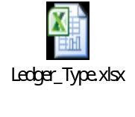

ODI Code Changes:
SDE Code changes for Ledger Type and Ledger Description:
Step-1:
Create a new temporary interface SDE_WC_Stage_LedgerTypeDimension.WC_LEDGER_TYPE_DS_SQ_XXC_LEDGER_TYPE_V.This interface loads the data from XXC_LEDGER_TYPE_V into SQ_XXC_LEDGER_TYPE_V Table

Step-2:
Create a new interface SDE_WC_Stage_LedgerTypeDimension.WC_LEDGER_TYPE_DS, which loads the data from
SQ_XXC_LEDGER_TYPE_V into WC_LEDGER_TYPE_DS table.

SIL Code Changes for ledger Type and Description:
Step-1:
Create a new interface SIL_WC_LedgerTypeDimension.WC_LEDGER_TYPE_D which loas the data from WC_LEDGER_TYPE_DS into WC_LEDGER_TYPE_D table

Fact Related Changes:
SIL Changes:
Step-1:
In the existing SDE_ORA_GLJournalsFact.W_GL_OTHER_FS_SQ_GL_JE_LINES interface add a column X_LEDGER_TYPE to SQ_GL_JE_LINES.
Step-2:
In the existing SDE_ORA_GLJournalsFact.W_GL_OTHER_FS interface add X_LEDGER_TYPE column and map the column as below.

SIL Changes for W_GL_OTHER_F:
Step-1: In the existing SIL_GLOtherFact.W_GL_OTHER_F interface populate Ledger_Type_WID and WC_JE_CATEGORY_D columns.

Lookup Condition for X_LEDGER_TYPE_WID:
SQ_W_GL_OTHER_FS.X_LEDGER_TYPE=WC_LEDGER_TYPE_D.LEDGER_TYPE_CODE
and
SQ_W_GL_OTHER_FS.DATASOURCE_NUM_ID=WC_LEDGER_TYPE_D.DATASOURCE_NUM_ID

Lookup Condition for X_JE_CATEGORY_WID:

SQ_W_GL_OTHER_FS.JOURNAL_CATEGORY=WC_JE_CATEGORY_D.JE_CATEGORY_CODE
AND
SQ_W_GL_OTHER_FS.DATASOURCE_NUM_ID=WC_JE_CATEGORY_D.DATASOURCE_NUM_ID

Data Model
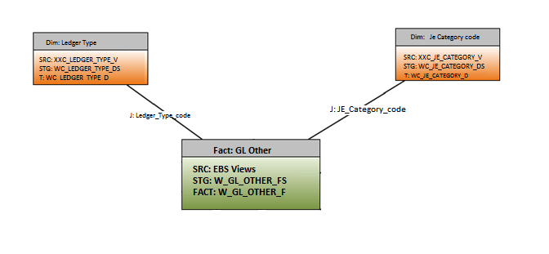

Add Ledger Type and Journal Category to 'Financials - GL Detail Transactions' Subject Area
The following columns are added to the Financials – GL Detail Transactions Subject Area to the “Document Details” folder.
Ledger Type
Journal Category Code
Journal Category Description

Journal Category Code and Journal Category Description are currently loaded into the Pre Allocated Expense subject area and may use the same EBS fields to source the extension columns in the new subject area.

Technical Overview
Ledger Type , Journal Category Code and Journal Category Description Columns to be added to the Financials – GL Detail Transactions Subject Area to the “Document Details” folder only.
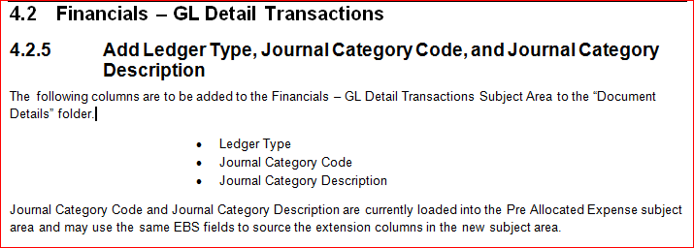

RPD Design
This section explains the technical implementation in the RPD

Physical Layer
Import newly created WC_LEDGER_TYPE_D table.
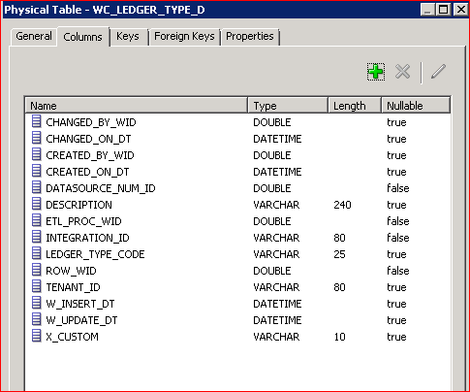
Create Alias for WC_LEDGER_TYPE_D table in Physical Layer

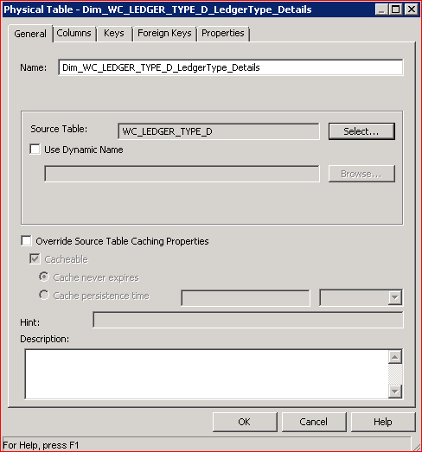

Create physical joins between Fact_W_GL_OTHER_F to Dim_WC_LEDGER_TYPE_D_LedgerType_Details and Dim_WC_JE_CATEGORY_D as shown below picture

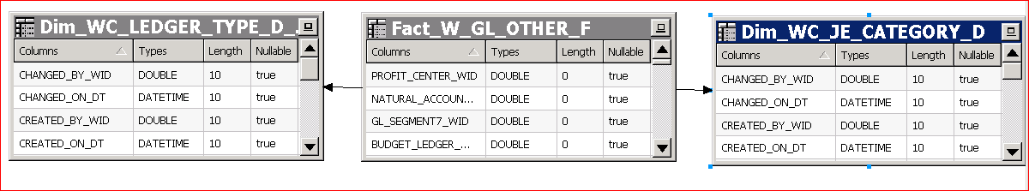

Join condition:
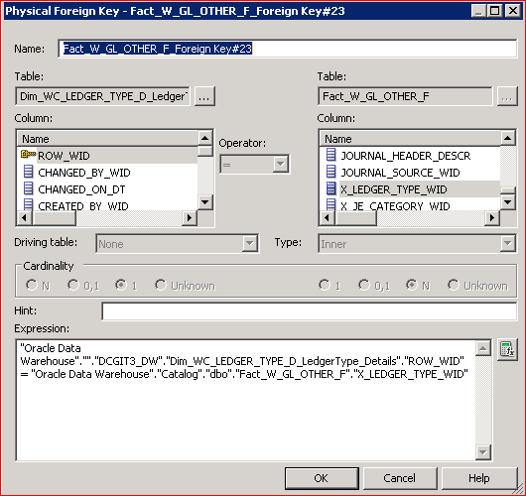

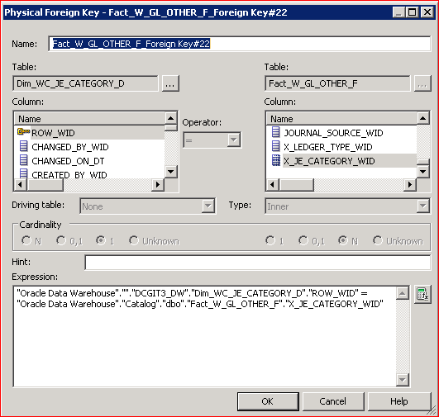

Physical diagram

BMM Layer
Bring newly created ‘Ledger Type’ dimension to BMM layer and create logical joins as shown below
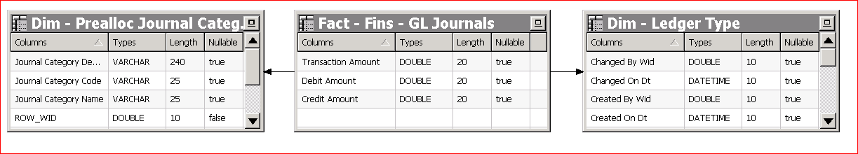

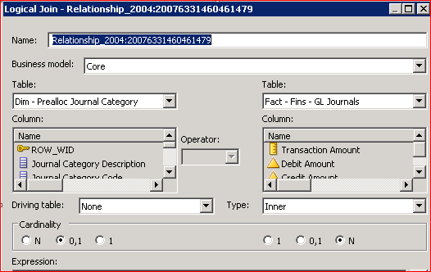

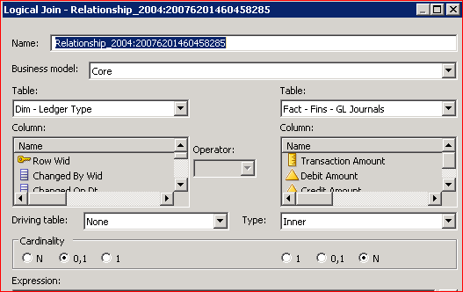
Set content Level at detail level for ‘Dim - Ledger Type’ and ‘Dim - Prealloc Journal CategoryDim’ logical dimensions
BMM Fact: Fact_W_GL_OTHER_F
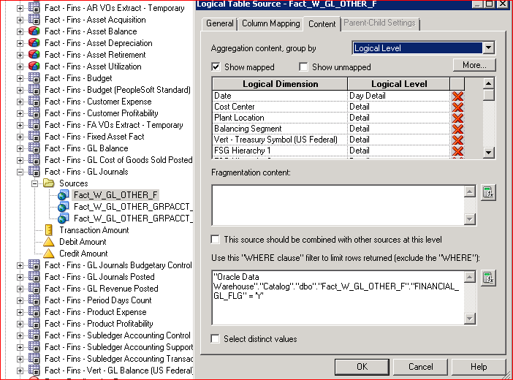

Presentation Layer
Pull 'Ledger Type', 'Journal Category Description' and 'Journal Category Code' columns from BMM layer to presentation layer as shown in below picture.
Subject Area Name: Financials – GL Detail Transactions
Folder Name: Document Details
